Grade 2 Homework Grid – Week 2

Reading  Read a book for 15 minutes every day. Make sure that you choose a ‘good fit’ book. | Who We Are  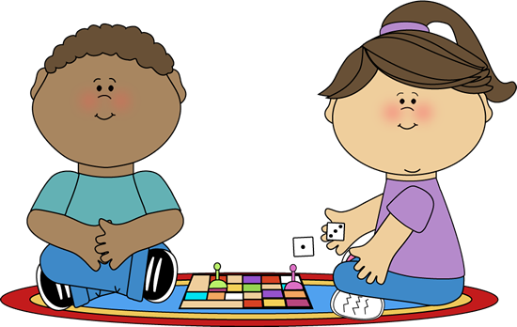  Play a game two times with your family. The first time, play the game in silence (don’t give any instructions or clues). The second time, you are allowed to play the game and talk while playing it. Ask your family what they thought about both games.
Learner Profile Attributes  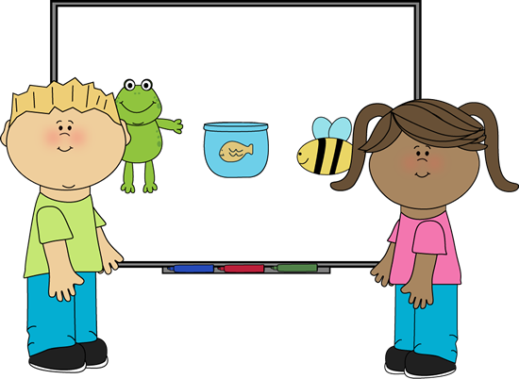  Communicator – Think about all of the different ways that you communicate. Be ready to share this with the class on Friday. | Learner Profile Attributes  Communicator – When you are out and about, practise the vocabulary that you have been learning in Mandarin.

